  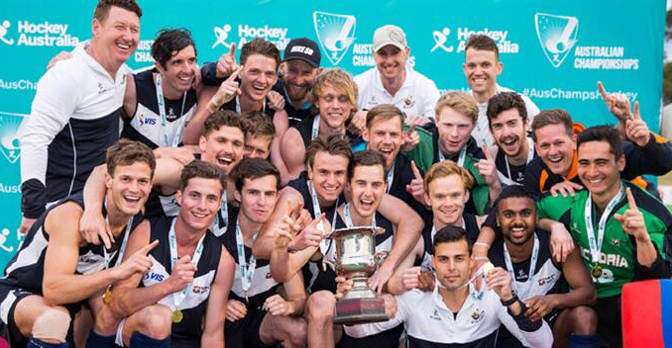
    - December 3rd – 4th
  Chris ciriello coaching clinics
  Albury clinics 2016
  Dual Olympian Chris Ciriello is heading back to his home city, Melbourne Victoria. Chris is a world leading drag flick specialist who knows what it’s like to compete under pressure.
  With 194 International caps and 115 Goals for the Kookaburras, Chris will be able to critique your current form and offer you personalised advice to improve your performance.
  Contact Lou Ciriello ASAP to book your club in for a session with Chris. The Ciriello Coaching Academy will provided General Field Play, Goal Keeping Coaching, Coaching the Coaches and White Board Session. Chris will also make himself available for signatures and selfies with the participants.
  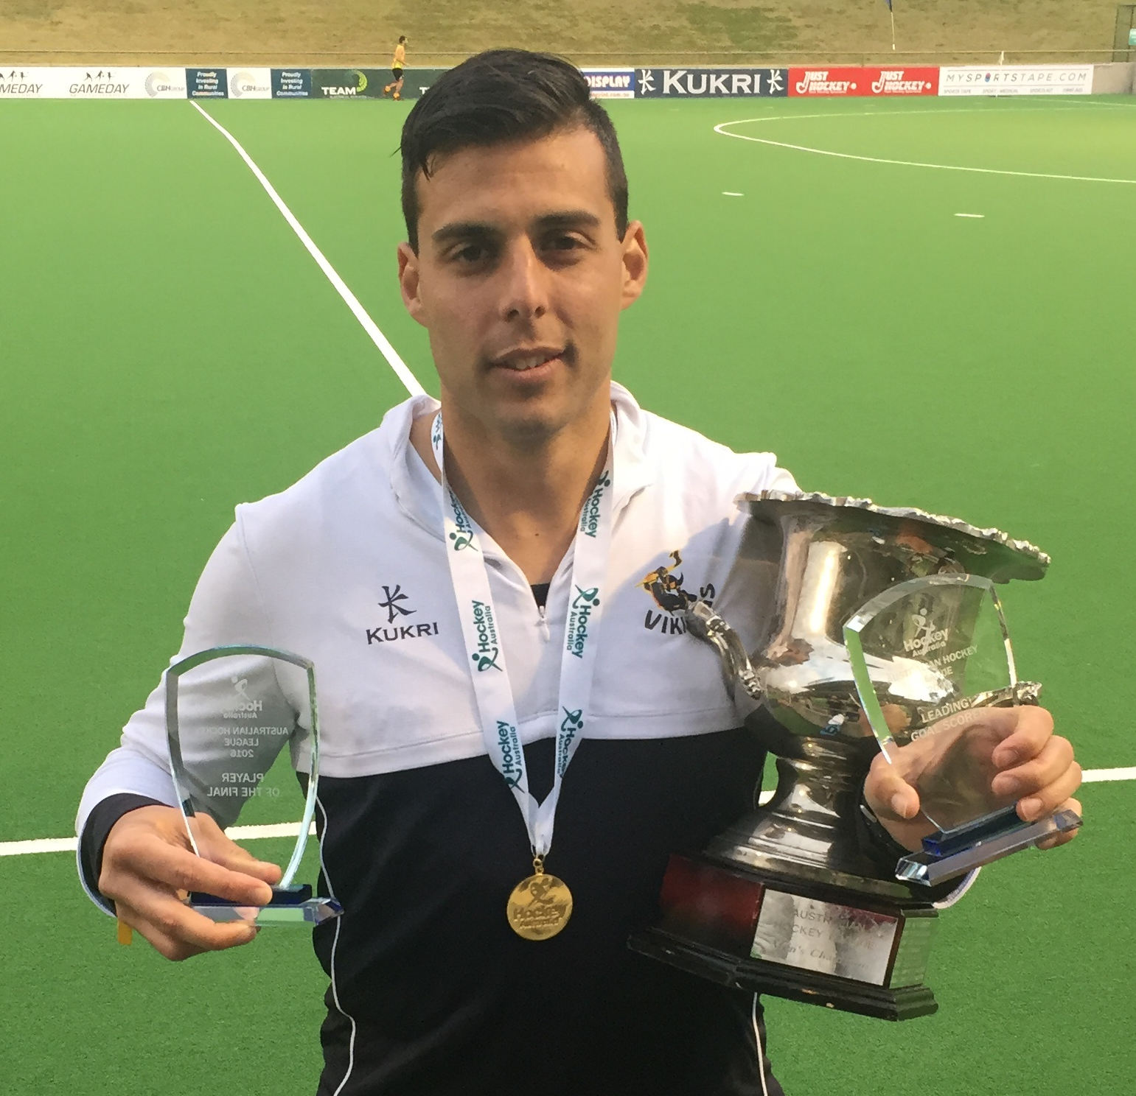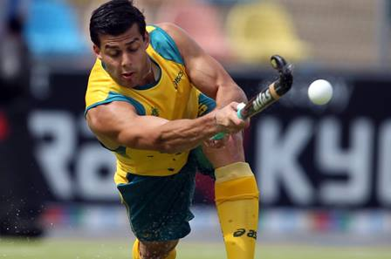
  Chris Ciriello is the CEO of Ciriello Coaching Academy.
  Book Chris in for a session at your club.
  Limited spaces and limited sessions.
  Be quick so you don’t miss out!
  Contact Lou for more information and to book a session.
  Lou ciriello
  Mobile:
  0430 123 502
  Email: lou@ciriellocoachingacademy.com

