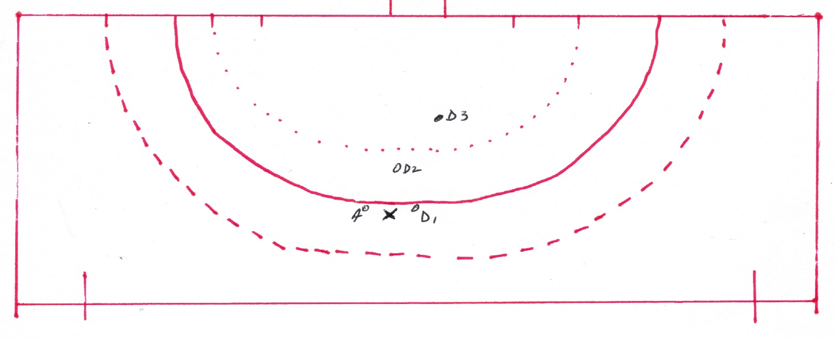
Free Hit within 5 metres of the Circle

Example: Free Hit (x) to A on the edge of the circle against D1
D2 is 3 metres inside the circle
D3 is 8 metres inside the circle
Where can the defenders move to?
D1 can either: move away from circle (5 metres from the free hit)
Or move into the circle and may stand on the inner edge of the circle near the free hit.

D2 can either remain in their current position, but cannot move any closer to the free hit
Or move 5 metres away from the free hit

D3 can move anywhere but no closer than 5 metre to the free hit.

Neither D2 nor D3 are allowed to move up to the edge of the circle near the free hit.
All other players must be at least 5 metres form the free hit.

Attacking team play the ball
- Must dribble the ball 5 metres (umpire to call “gone 5”) before the ball can enter the circle. Rolling the ball 5 metres then hitting/slapping into the circle is not acceptable, or
- Pass the ball which must be touched by another player (either team) before the ball enters the circle.

